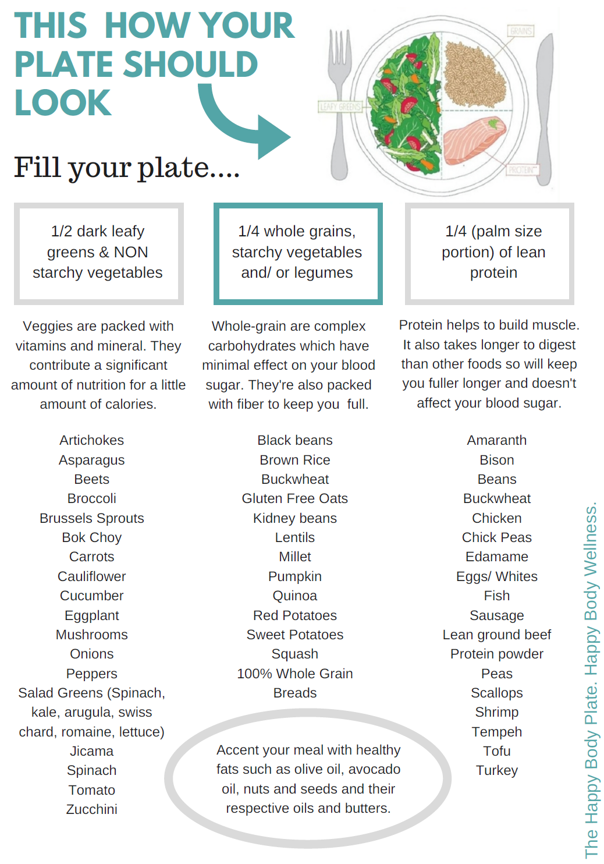

Happy Body Lean Shopping List
PROTEIN | COMPLEX CARBOHYDRATES | FRUITS & VEGETABLES
MEAT  Bison (18 g per 3 oz)  Chicken Breast (24 g per 3 oz)  Ground Beef, lean steak (23 g per 3 oz)  Pork Chops, lean (24 g per 3 oz)  Steak (23 g per 3 oz)  Turkey Breast (24 g per 3 oz)  DAIRY & EGGS  Cottage Cheese (14 g per 1/2 c)  Eggs (6 g per 1 large egg)  Greek Yogurt (23 g per 8 oz)  Milk (8 g per 1 cup)  Swiss Cheese (8 g per 1 oz)  Whey Protein (25 g per scoop)  SEAFOOD  Halibut (23 g per 3 oz)  Lobster (16 g per 3 oz)  Shrimp (26 g per 4 oz)  Sockeye Salmon (23 g per 3 oz)  Tilapia (21 g per 3 oz)  Yellowfin Tuna (25 g per 3 oz)  CANNED FOODS  Anchovies (24 g per 3 oz)  Chicken (21 g per 3 oz)  Light Tuna (22 g per 3 oz)  Sardines (21 g per 3 oz)  MEAT ANALOGS  Seitan (21 g per 3 oz)  Tempeh (16 g per 3 oz)  Tofu (12 g per 3 oz)  MISC  Dried Lentils (13 g per 1/4 cup)  Edamame (8 g per 1/2 cup)  Jerky (13 g per 1 oz)  Mixed Nuts (6 g per 2 oz)  Navy Beans (20 g per 1 cup)  Peanut Butter (8 g per 2 tbsp)  Quinoa (8 g per 1 cup)  Soba Noodles (12 g per 3 oz)  Wheat Germ (6 g per 1 oz) | Amaranth  Barley  Beans (black, kidney, etc)  Bean Pasta - lots of brands  Bulgur  Couscous  Dried chickpeas  Farro  High-fiber cereal (Raisin Bran, Kashi, Ezekiel, Cheerios, Fiber One)  Kamut  Lentils  Millet  Oatmeal / steel cut oats  Popcorn - whole grain  Potato  Pumpkin  Quinoa  Rice (Black, Brown, Wild, Red)  Sweet potato/yams  Squash  Teff  Whole wheat bread (Ezekiel,  Arnold Whole Wheat, Nature’s Harvest)  Whole wheat tortillas  Whole what pita bread  Whole wheat pasta  Whole grain crackers (Triscuit  Crunch Master, Quinoa Crisps, Mary’s Gone Crackers)  Wild rice (aka black or forbidden) | VEGETABLES  Artichoke  Asparagus  Broccoli  Brussels sprouts  Cabbage  Carrots  Cauliflower  Celery  Cucumber  Green beans  Green peppers  Lettuce  Mushrooms  Onion  Peas  Spinach  Tomato  Zucchini  FRUITS  Apple  Apricots  Banana  Berries (Straw, Black, Blue, Rasp)  Cherries  Cranberry  Grapes  Kiwi  Lemon, Lime, Grapefruit  Mango  Melon  Mulberry  Nectarine  Peach  Pear  Pineapple  Plum  Prunes  Tangerine/Clementine/ Orange
Sample Meal Plan
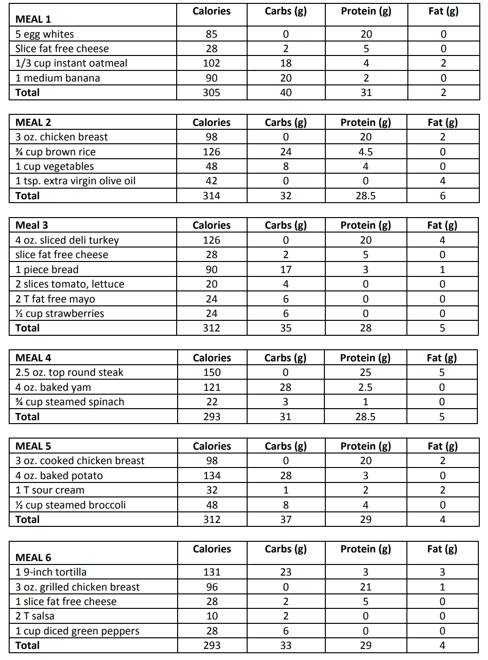

1500 Calorie Sample Meal Plan

